1. We are looking for a site like https://duck.design/ which should be responsive (good for mobile, tab, laptop etc).  
  
2. Use attached wp template kit.  
  
3. Below are pages.  
Home Page  
Pricing  
Our Services   
Our Work (Samples-Creative, Sample – Video, Sample – Website)  
Blog  
Contact  
  
4. At top right corner there will be no social media icons. On that place, please make a button of 🡪 Quote Request.

5. Home Page   
  
**Hero section**- Left side content  
From Social Posts to Stunning Websites — We Design It All!

- Below the text  
Button (Find Your Perfect Plan) ( clickable button and redirect to pricing page )

- Right side 4 Graphic will change rendomly. There will be no text on right image.

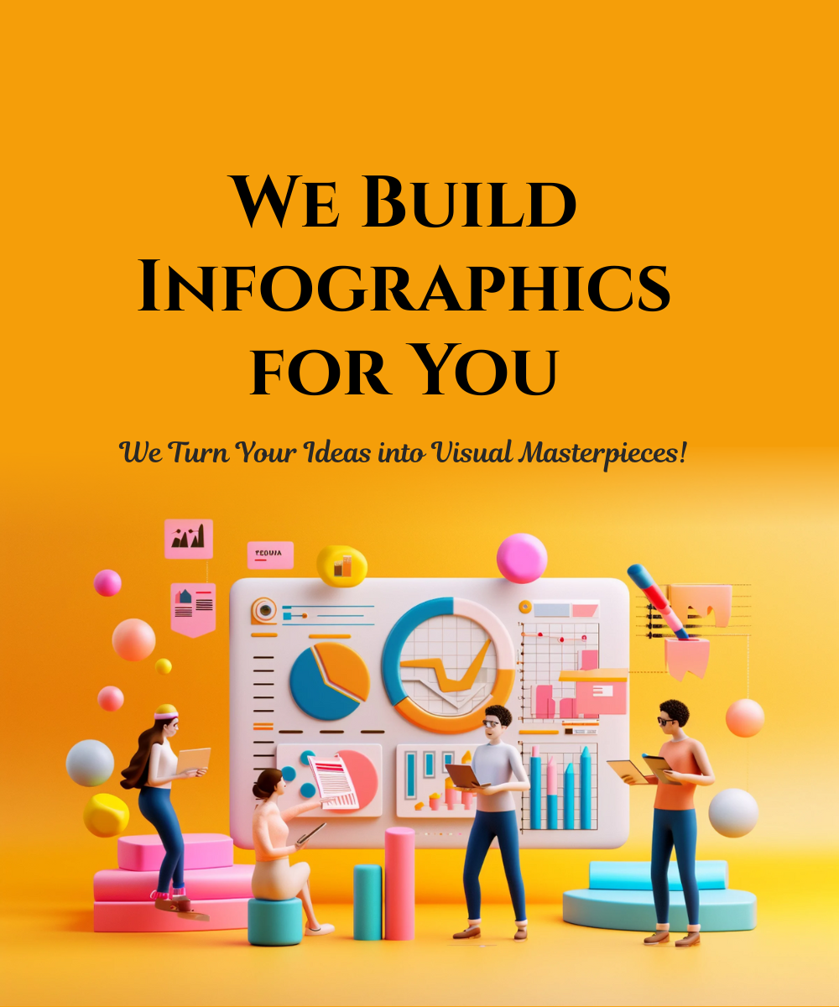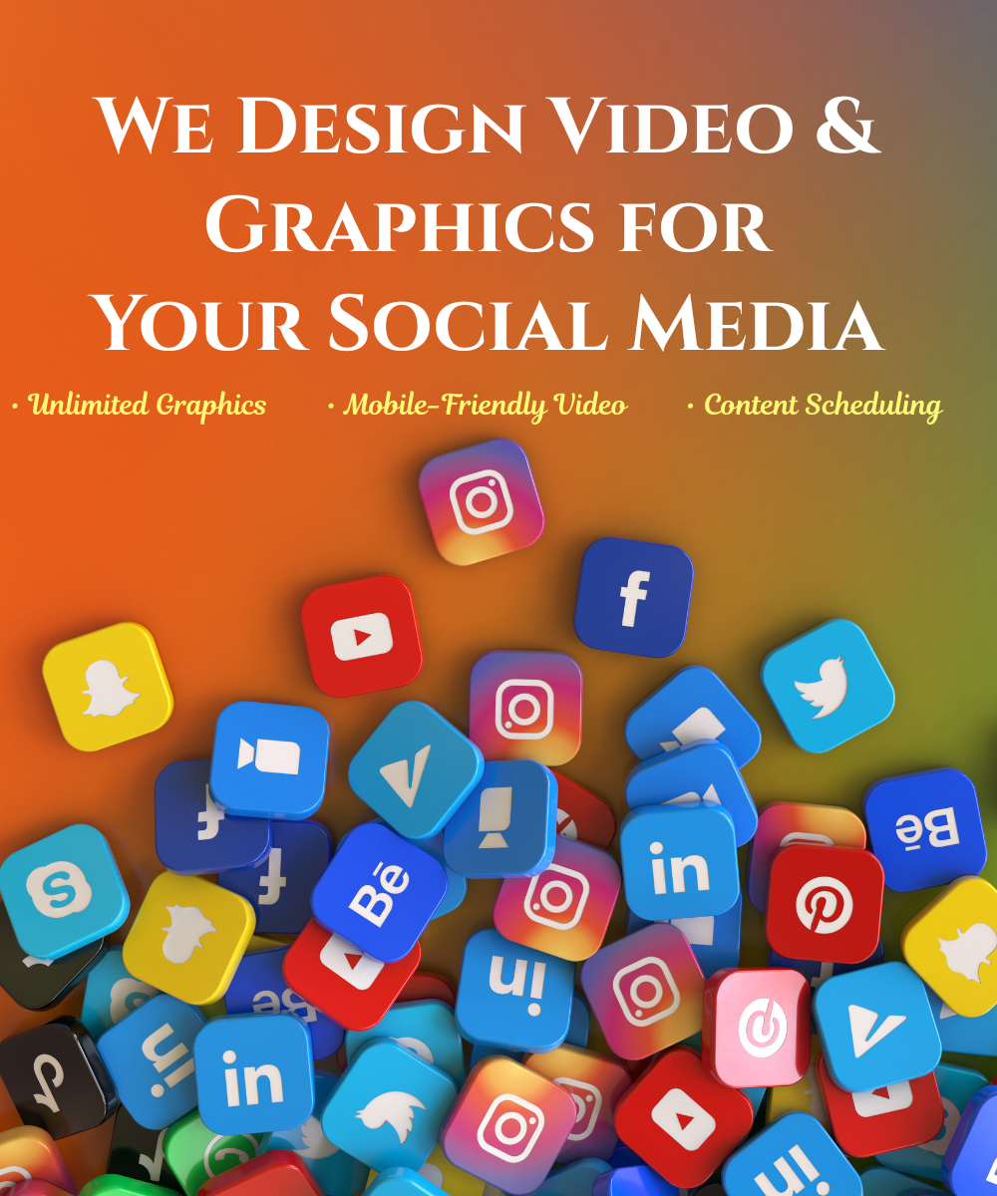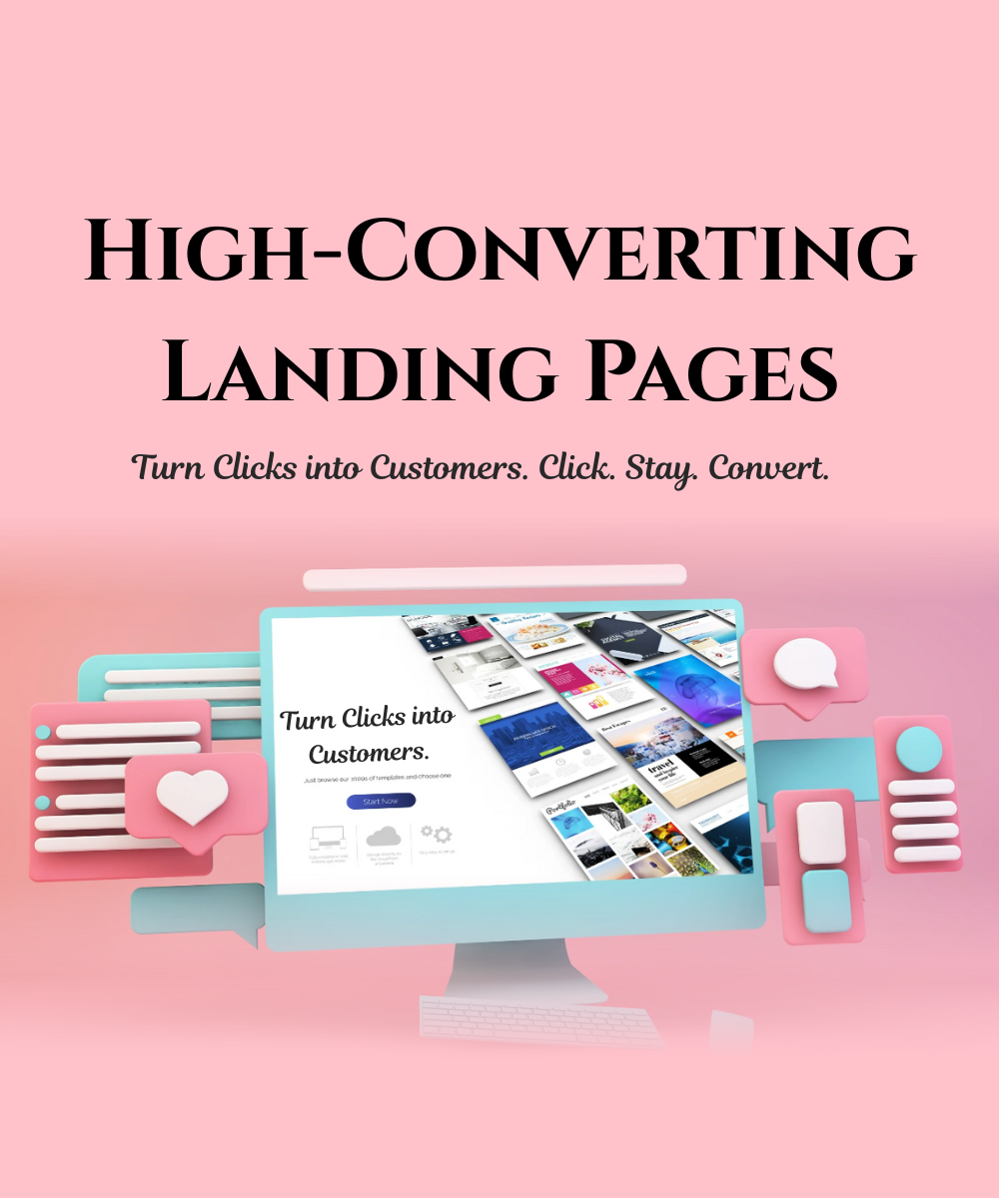  
  
-------------------

**Below Hero Section 🡪 at this place 🡪 use our images, given below  
  
  
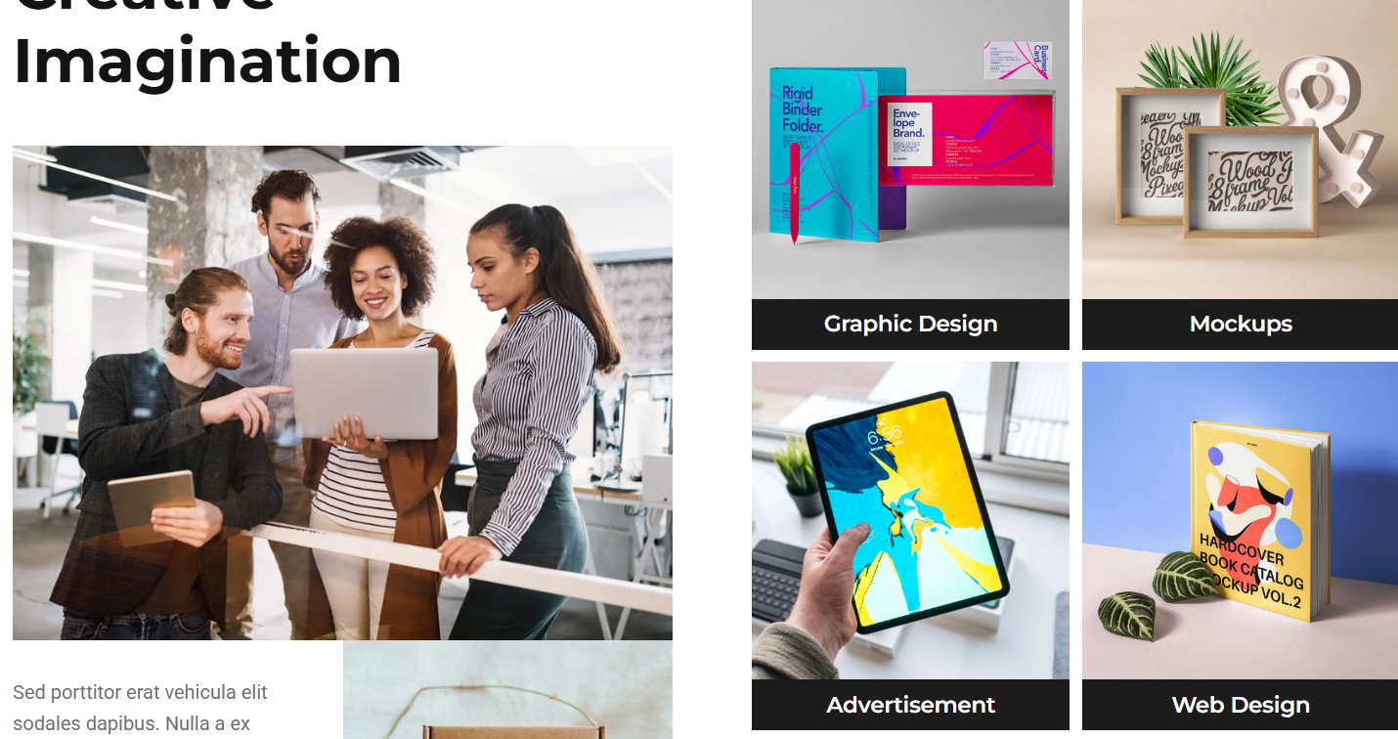  
  
** Creative Design ****Video 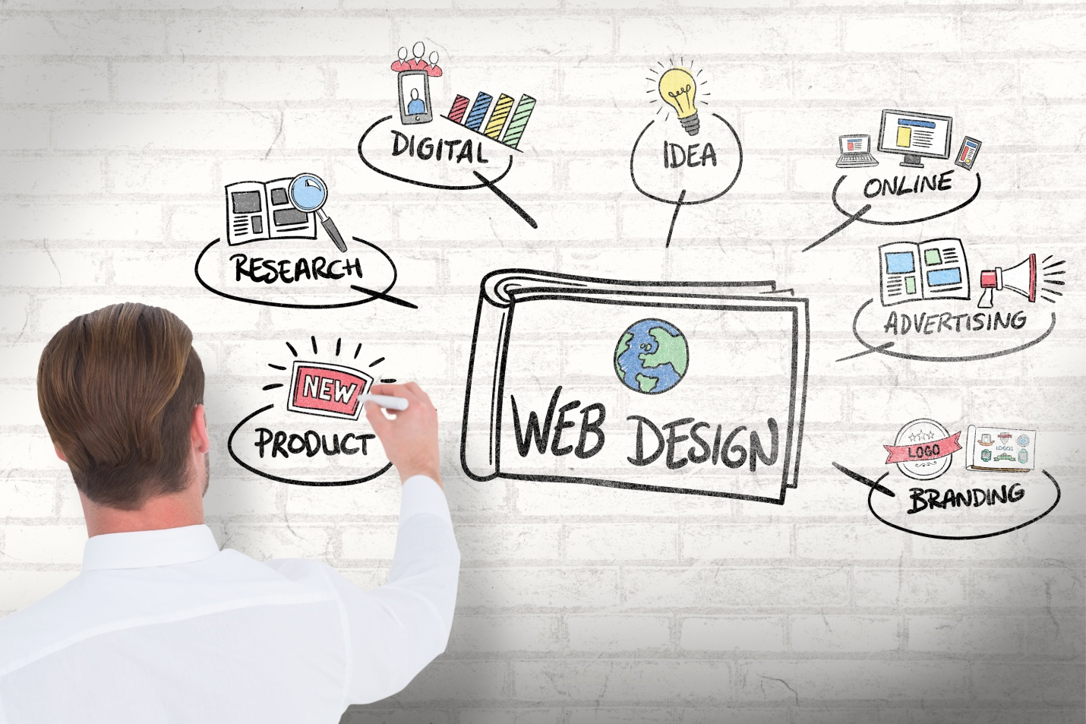Website 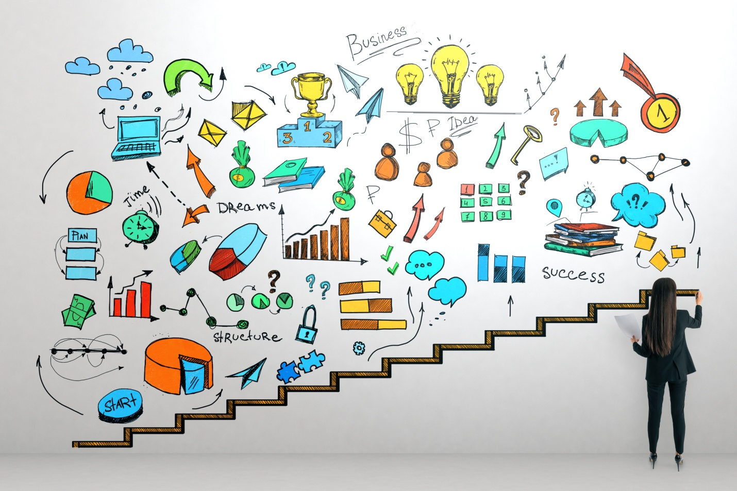Infographics **(this will be left top image)  
  
(left bottom image)**

Our Services  
We design scroll-stopping Facebook ads, engaging videos, sleek websites, and high-converting landing pages — built to grow your business.  
- All Designs at One Stop   
- Economical Cost  
- Unlimited Revisions at Same Cost  
 Start your project now  
  
  
Creative Design  
Video  
Website  
Infographics  
  
  
✔ Eye-Catching Social Media Creatives

✔ Branded Videos That Tell Your Story

✔ Free Website Design with Every Package

✔ Engaging & Clean Infographics

--------------------------------------

Contact Now  
+1-780-604-0574 (Call Link)  
+1-780-604-0574 (WhatsApp Link Message)

**For Your Growth (at place of Since 2000)**

- Smart Designs

- Bold Strategies

- Real Results  
------------------------  
In template, do not use this part.  
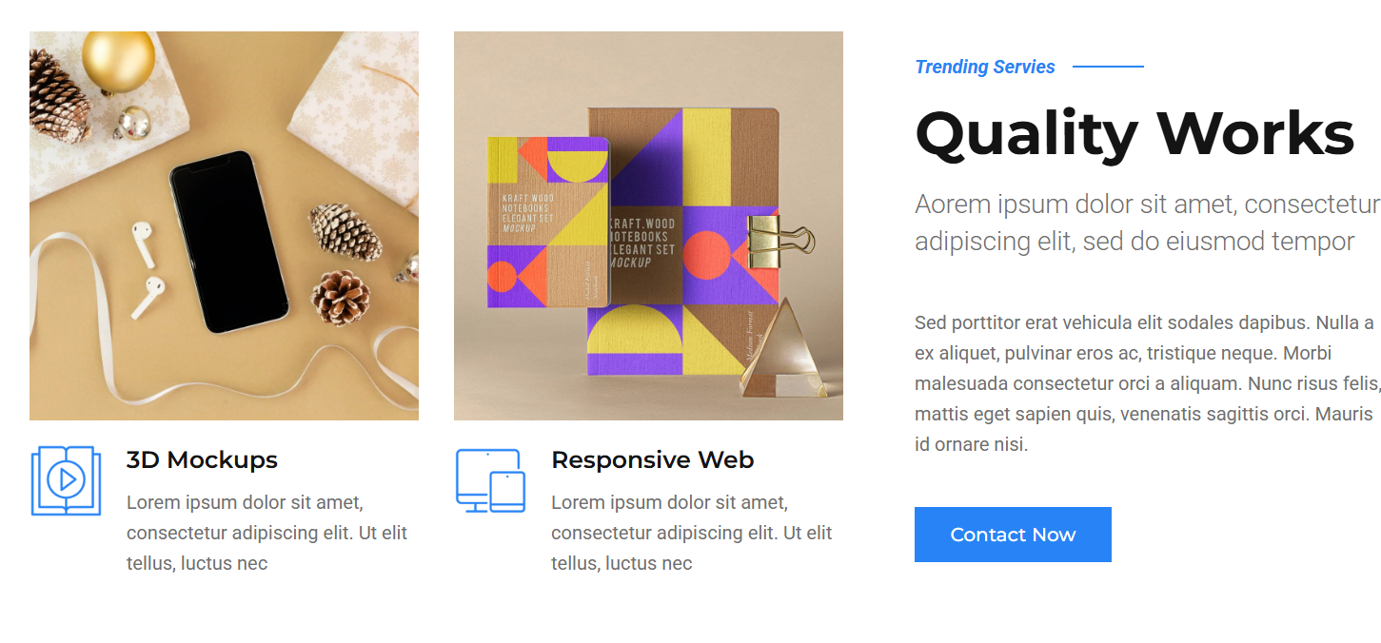  
Rather, use this. 🡪  
Show images, moving like they are moving at <https://duck.design/> under heading, “Our Works”.   
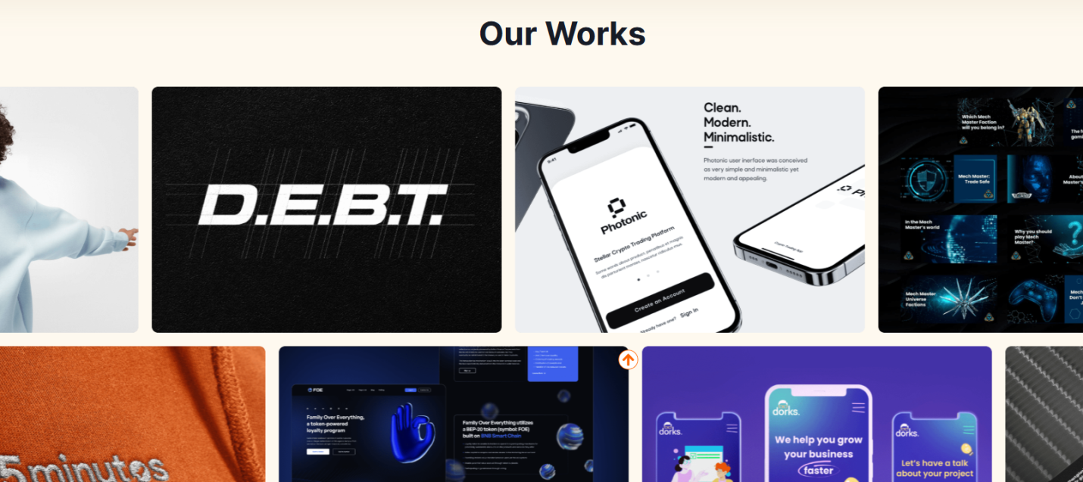  
-----------------  
Below it, use this part.  
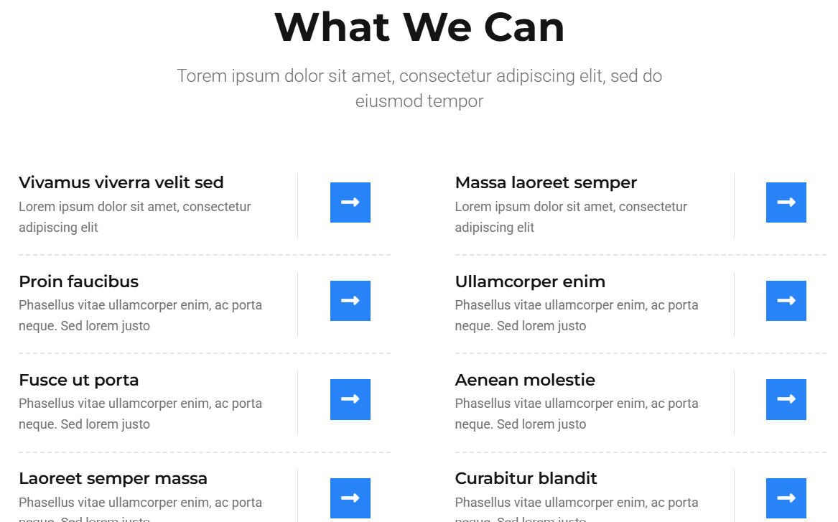  
  
This is the matter. Numbering required 1, 2, 3.

|  |  |
| --- | --- |
| 1 | 2 |
| 3 | 4 |
| 5 | 6 |
| 7 | 8 |

### ****Get Started Today — It’s Simple!****

**1. Choose the Right Plan for You**  
Pick a plan that fits your goals, timeline, and budget.  
No pressure — just what works best for your business.

**2. Secure Your Spot**  
Complete the payment quickly and safely.  
You’re one step closer to professional design help.

**3. Start with Confidence**  
Right after payment, your personal project manager will connect with you.  
They’ll guide you through everything and help you get started smoothly.

**4. Share Your Vision**  
Fill out a quick brief to tell us about your brand, goals, and style.  
This helps us deliver exactly what you need.

**5. Submit Your First Task**  
Have something in mind?   
Send us the details — logos, text, images — and we’ll get to work.

**6. See the Results, Fast**  
Get your design. Need tweaks?   
No problem. We revise until you’re happy.

**7. Approve and Move Forward**  
Once you're satisfied, your task is marked complete.

**8. Keep the Momentum Going**  
Ready for more?   
Submit your next task anytime. We're here when you need us.

------------------  
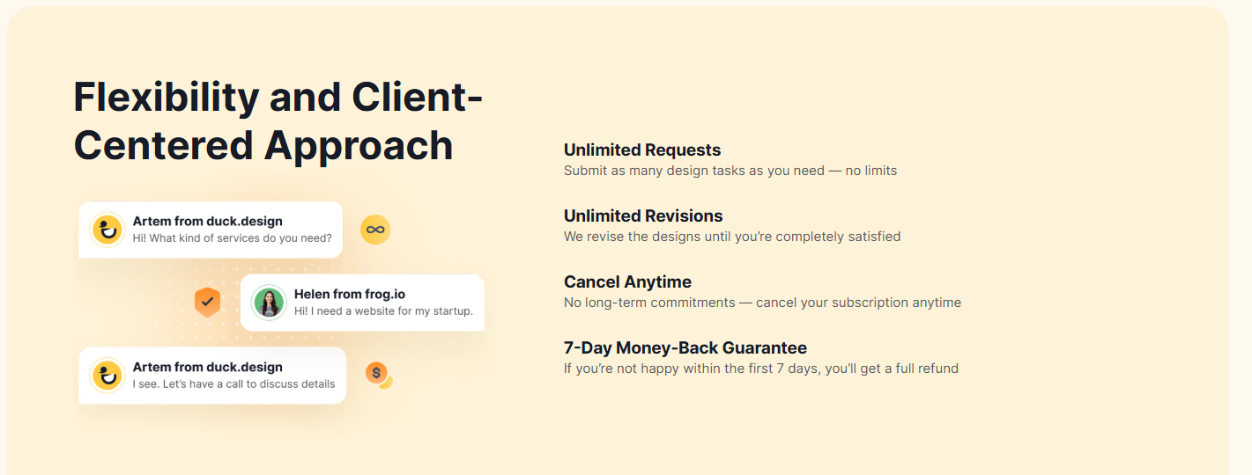  
-------------  
Use this video and put below given text on it   
  
Ready to Get Results?

Let’s Make It Happen

Choose a package now and unlock unlimited design power.

No delays. No limits. Just results.

[SELECT YOUR PLAN] ( clickable button and redirect to pricing page )  
  
--------------------  
  
Use this structure

### Remove this group image and use this graph image. D:\new-website\images\2051ac51-95aa-48c4-a92d-bd0aab61bf9c.jpg 💡 Why Choose Us?

We don’t just design — we solve problems. Our creatives and videos are built to **grab attention, build trust**, and **drive real business results**.

✅ Daily fresh content to keep your brand visible  
✅ Designs tailored for U.S. market trends  
✅ One-stop solution for graphics, video & web design  
✅ Save time, reduce costs, grow faster

Let us handle the visuals — so you can focus on growing your business.  
-----------------

Reviews - Randomly changing (one at a time) (match images with names, girl image with Jessica, Sarah and male image with mark and devid)  
  
**1.**  
  
*"Working with* ***A Digital Growth****, transformed our social media presence. The creatives are fresh, engaging, and perfectly tailored for our audience. Highly recommend for anyone wanting real growth!"*  
— Jessica M., Marketing Director, Texas

**2.**  
  
*"The video content they created for our product launch was outstanding — professional, on time, and delivered exactly what we needed to boost sales."*  
— Mark T., E-commerce Entrepreneur, California

**3.**  
  
*"Their Amazon listing designs and A+ content helped increase our conversion rates significantly. They understand Amazon’s specs and what sells."*  
— Sarah L., Small Business Owner, New York

**4.**  
  
*"Fast turnaround, excellent communication, and quality work every time. We consider them an essential part of our marketing team."*  
— David R., Startup Founder, Florida  
  
-----------------------------------------  
  
Footer  
  
Ending of home page  
++++++++++++++++++++++++++++++++++  
++++++++++++++++++++++++++++++++++  
  
Pricing Page  
  
Below is an image with 4 links (Agencies, Small and medium…). By clicking on each, different matter appears. Use it the same way. Put any dummy matter.   
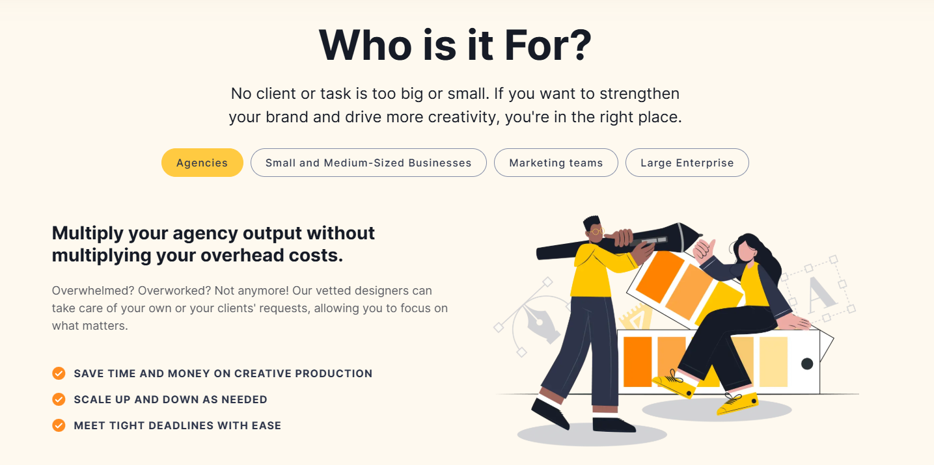  
Use this layout 🡪 <https://duck.design/pricing/> (use our services, given below)

Use same structure as shown below (1 month, 6 months, 12 months)   
Use our details (given below)  
Do not use same color theme. Use Black and Blue theme.  
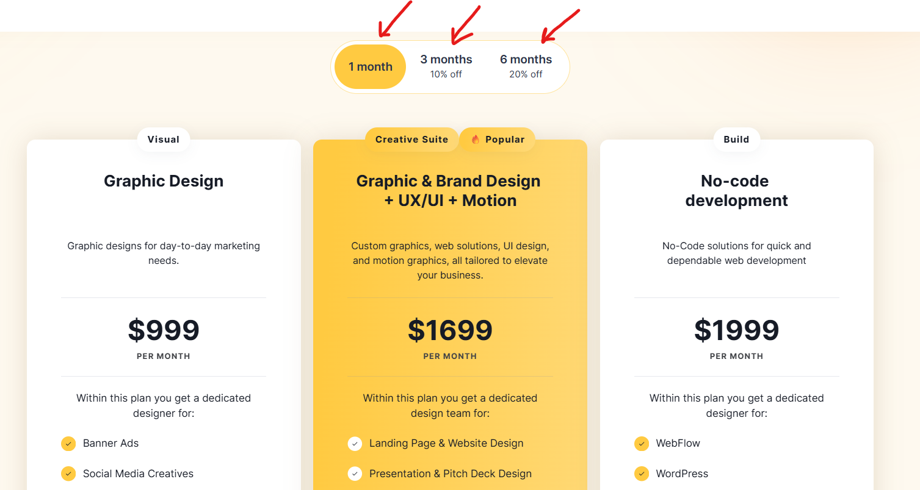

|  |  |
| --- | --- |
| **INCLUDED IN ALL PLANS**  Every plan package offers  We handle all your creative needs  You Do Not Worry About Freelancers, Hiring Delays, Just Results.  - Unlimited requests  - Real-people working on your projects  - Unlimited revisions  - Unlimited brand profiles  - 7-day money-back guarantee  - Cancel anytime | **D:\new-website\images\word-save-circled-red-list-spending-surrounded-by-pencils-graphs-books-calculator.jpg** |

|  | **Monthly** | **6 Month – 10% Off** | **12 Month – 20% Off** |
| --- | --- | --- | --- |
| **Monthly Price** | $50/month | $40/month | $30/month |
| **Upfront Billing** | Monthly | 6 Month | 12 month |
| **Website** | FREE Small Website (included) | FREE Medium Website (included) | FREE Better Website (included) |
| **Hosting** | Free (included) | Free (included) | Free (included) |
| **Social Media Creatives** | YouTube Facebook Insta Twitter Tik Tok (any 2) | YouTube Facebook Insta Twitter Tik Tok (any 3) | YouTube Facebook Insta Twitter Tik Tok (any 4) |
| **Social Media Videos** | YouTube Facebook Insta Twitter Tik Tok (any 2) | YouTube Facebook Insta Twitter Tik Tok (any 3) | YouTube Facebook Insta Twitter Tik Tok (any 4) |
| **Priority Support** | — | — | Yes |
| FREE (Last weeks of every annual contract) | 1 Week Free | 2 Week Free | 4 Week Free |
| Website Designing | Free (included) | Free (included) | Free (included) |
| Hosting | Free (included) | Free (included) | Free (included) |
| Domain Name Registration | Free (included) | Free (included) | Free (included) |
| SSL Certificate | Free (included) | Free (included) | Free (included) |
| Mobile Optimization | Free (included) | Free (included) | Free (included) |
| Contact/Inquiry Form | Free (included) | Free (included) | Free (included) |
| Business Email Setup |  | Free (included) | Free (included) |
| Basic SEO Setup |  | Free (included) | Free (included) |
| Google Analytics Integration |  | Free (included) | Free (included) |
| Website Backups |  | Free (included) | Free (included) |
| Social Media Linking |  | Free (included) | Free (included) |
| Copyright-Free Stock Images/Videos for your creative/video | Yes | Yes | Yes |
| WhatsApp Chat Widget Integration |  |  | Free (included) |
| Monthly Performance Report |  |  | Free (included) |
| Priority Support |  |  | Free (included) |
| Discount Offers |  |  | Free (included) |

Below that, put same scrolling image, that you used at home page

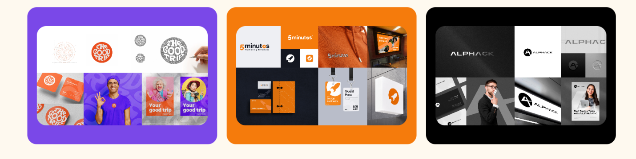  
Use below, with new wordings and new graphics  
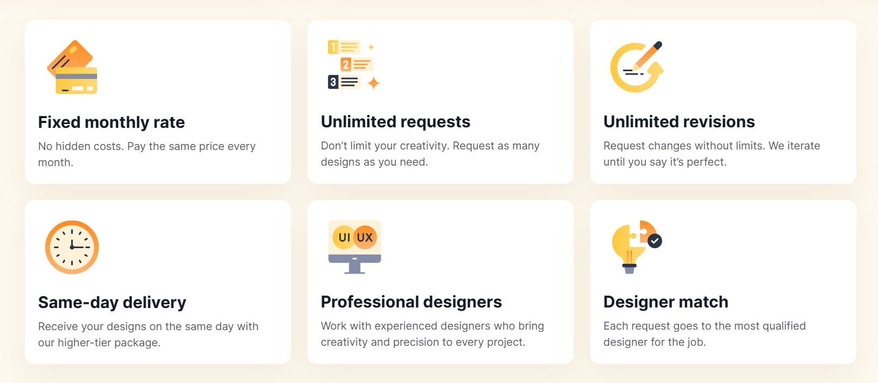

Below that, put FAQ (similar to <https://duck.design/pricing/> ) by using below question and answers

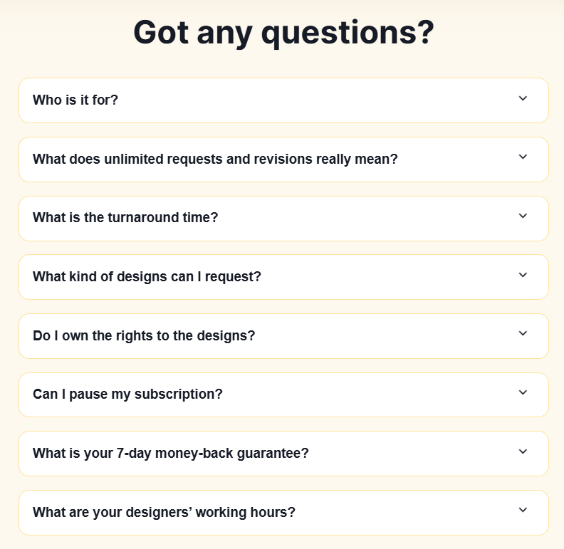

Frequently Asked Questions

**Who is A Digital Growth for?**  
A Digital Growth is perfect for any business or entrepreneur—whether you’re just starting out or already growing. We’re your go-to team for affordable, high-quality design and digital services. With us, it feels like you have your own in-house creative team, but without the high costs.

**What does unlimited requests and revisions mean?**  
Send us as many design requests and revisions as you want—your price never changes. Our team works Monday to Saturday, 8AM–8PM (Edmonton time) to deliver quality designs promptly.

**Need faster service?**   
Ask about our Exclusive Pro plan for priority support and quicker turnaround. Let us handle your design needs while you focus on growing your business!

**How fast will I get my designs?**  
Most requests get their first update within 24 working hours. For bigger or more complex projects, it might take up to 48 working hours or more. We work hard to keep your business moving forward, six days a week.

**What kinds of designs can I request?**  
Depending on your plan, you can ask for almost anything, including:

* Website design
* Logo design
* Social media images
* Videos and GIFs
* Banners and ads
* Infographics
* Brochures and flyers
* And much more!

**Can I use the designs anywhere?**  
Yes! You are free to use anywhere you wish to use the designs we create for you. You get the ready-to-use formats (PNG/JPEG/SVG/PDF/MP4). Use them anywhere you want—no restrictions.

**Can I pause my subscription?**  
Absolutely! You can pause your subscription for up to 7 days during your third month—so you only pay for what you use.

**What’s your money-back guarantee?**  
Try us risk-free! If you’re not happy within the first 7 days, just let us know and we’ll refund your full membership fee—no questions asked.

**How much time does it take to get website design ready?**   
Within first 2 weeks, we get ready all the content for every page of your website with proposed images. After your approval, we proceed and get your first preview ready in 3rd week. You suggest corrections which we implement and deliver your final website after that.

**When is your team available?**  
Our team is here for you Monday to Saturday, from 8AM to 8PM (Edmonton, AB time zone). You’ll always get quick responses and reliable service.

**Ready to grow your business with A Digital Growth?**  
Let’s make your brand stand out—get started today!

Example FAQ for Your Clients

***Q: What does "unlimited designs" mean?*** *A: You can submit as many design or revision requests as you want. We work on one request at a time for each client. As soon as one is finished, you can submit another.*

***Q: How do I submit my requests?*** *A: Just email us your request. We’ll add it to your queue and start working on it as soon as your turn comes up.*

***Q: How long does each design take?*** *A: Turnaround depends on the current pipeline and complexity of your request. We’ll always keep you updated on your place in the queue.*

***Q: Can I request revisions?*** *A: Yes, unlimited revisions are included! Each revision goes back into the queue and will be handled in turn.*

***Q: What if I need something urgently?*** *A: All requests are first-come, first-served. If you need faster service, ask us about our higher-tier plans for priority support.*

Book Package.  
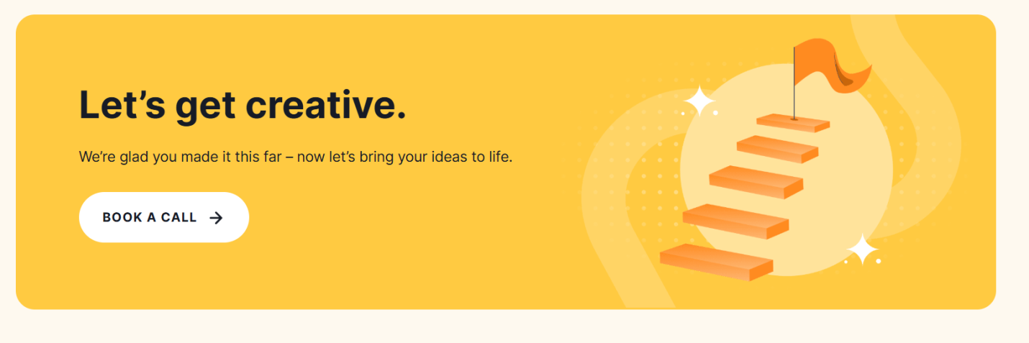

+++++++++++++++++++++++++++++++

+++++++++++++++++++++++++++++++

Services Page  
  
Use it  
<http://templatekits.c-kav.com/demo2/gild/template-kit/services-1/>   
  
**Consistent, high-quality design support — so you never fall behind.**  
We act as your on-demand creative team, delivering daily graphics, videos, and digital assets that keep your brand active, sharp, and growing — without the cost of hiring in-house.  
  
- Social Media Creatives   
Daily branded graphics for Facebook, Instagram & LinkedIn that boost engagement.   
  
- Video Design   
Powerful Short-form videos, reels & promos tailored to capture attention and convert.   
  
- Website & Landing Page Design   
Clean, modern layouts optimized for speed, UX, and sales.   
  
- Infographics & Data Visuals   
Turn complex ideas into visually compelling, easy-to-share graphics.   
  
- Ad Creatives (Meta & Google)   
Designs that convert — built for paid campaigns that perform.   
  
- Banner & Display Ads   
Static and animated banners for web, apps, and digital campaigns.   
  
- A+ Content (with Graphics) for Amazon Listings  
Enhanced product pages designed to increase conversions and brand trust.  
  
- Amazon Product Listing Design  
Optimized visuals crafted to meet Amazon specs and boost your sales

Built for Results  
**Creative Work That Delivers Results**  
Take a look at the real impact of our designs — crafted to elevate brands, capture attention, and drive conversions across every platform.

* **Social Media Creatives**: Daily visuals built to boost engagement and visibility.
* **Video Design**: Eye-catching branded videos that tell your story powerfully.
* **Website Design**: Clean, conversion-focused websites made to impress and perform.
* **Infographics**: Clear, compelling data visuals for smarter communication.

Services We Offer

1. **Social Media Post Designs**  
   Attractive images and graphics for your posts and stories, so your business stands out and gets more attention.
2. **Video Creation & Editing**  
   Engaging videos that make your brand or products easy to understand and more appealing—helping you get more views and followers.
3. **Website Designing**  
   Modern, easy-to-use websites that make your business look professional and help you reach more customers online.
4. **Content Post Scheduling**  
   We help you schedule your social media posting as what to post and when, so you never have to worry about regular updating. This saves you time, keeps your social media active, and helps you stay organized.

++++++++++++++++++++++++++++  
++++++++++++++++++++++++++++  
  
Our Work (Samples-Creative, Sample – Video, Sample – Website)

Our Work

<http://templatekits.c-kav.com/demo2/gild/template-kit/portfolio-2/>

++++++++++++++++++++++++++++++  
++++++++++++++++++++++++++++++

Blog  
  
Main page

http://templatekits.c-kav.com/demo2/gild/?elementor_library=archive

Each single blog link

http://templatekits.c-kav.com/demo2/gild/2019/08/28/qui-lorem-imperdiet-non-turpis-nec-congue-sagittis-mauris/

++++++++++++++++++++++++++++++++++++++  
++++++++++++++++++++++++++++++++++++++

+++++++++++++++++++++++++++++++++++++++++

++++++++++++++++++++++++++++++++++++++++++

Contact

http://templatekits.c-kav.com/demo2/gild/template-kit/contact-1/  
  
📞 +1-780-604-0574  
**Send WhatsApp Message Now (make it clickable for sending WhatsApp Message)**

### We are YOUR Team We’re excited to help you! Choose any package that fits your needs and budget. Let’s get started on growing your brand today.

✨ Simple. Flexible. Fast. Your vision, our design expertise.

🚀 Ready? Start Now!

* Also add a form (Name, Email, Phone, Message) goes to [aDigitalGrowthCanada@gmail.com](mailto:aDigitalGrowthCanada@gmail.com)

++++++++++++++++++++++++++++++++++++++

++++++++++++++++++++++++++++++++++++++